

Football & Multi-Sport May Holiday Course 2026
4-day Football & Multi-Sport holiday course for children age 4 – 14 years, Age appropriate groups in Football & Multi-Sports with Family Day & presentations on the Friday. Sessions run from 9.30am – 3pm every day, with drop off open from 9.15am. All our coaches are FA qualified, Licensed with DBS, First Aid & Safeguarding certification and public liability and professional indemnity insurance.

Age appropriate Football & Multi-sports & Mini Olympics
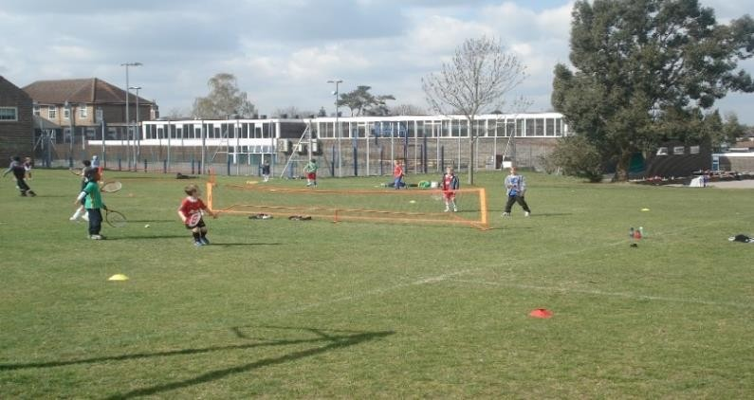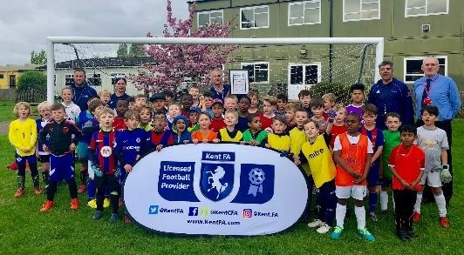

At £66+vat for a week of sports and fun, with family day and presentations on the final day, where every
child will receive a medal and final tournament winners a small trophy. For further information and registration forms or to book a place for your child visit www.prostarsfootball.co.uk or email prostarsfootball@hotmail.com for more details, places are limited so book early to avoid disappointment.
Marian Vian Primary 26th – 29th May 2026

Mobile 07957 949198 or Office 020 84646453 www.prostarsfootball.co.uk prostarsfootball@hotmail.com

