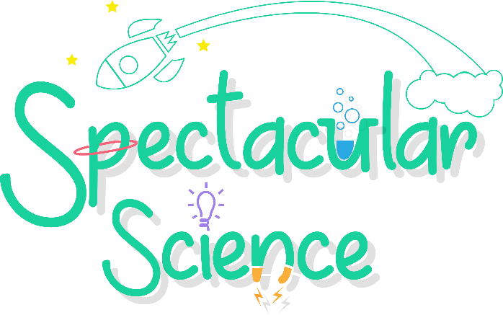

We are very excited to announce that Spectacular Science Club is returning to Marian Vian this Summer Term!
Spectacular Science Club is an after-school club that offers an hour of awesome fun in which children can learn more about the wonderful world of science. During each session, children are truly engaged with different hands-on science experiments, including rockets, slime creations, circuits, learning about the planets, magnets, tie-dying, lava lamps, marble runs, and lots, lots more!
Spectacular Science Club has been running since September 2018 and has proved to be a huge success. All teachers are fully trained and have enhanced DBS checks.
Sessions will be held after school from 3:10 pm - 4:25 pm.
Reception, Year 1-6 – Wednesday 22nd April – Wednesday 15th July 2026
If your child is interested in joining Spectacular Science Club, please sign up via the following link:
https://spectacular-science-club.classforkids.io/term/142
Kindest regards,
The Spectacular Science Team
admin@spectacularscienceclub.co.uk

